Lightweight Gaming Headphones without Mic: Comfort Meets Performance
Gaming has evolved into a multi-dimensional experience that engages our senses and transports us into immersive virtual worlds. While visuals play a crucial role, audio is equally important in creating a captivating gaming environment. For gamers seeking an exceptional auditory experience without the need for a microphone, lightweight gaming headphones without mic are the perfect choice. In this article, we will explore the benefits of these headphones and provide valuable insights on choosing the ideal pair for your gaming needs.

Introduction
When it comes to gaming headphones, many enthusiasts prioritize lightweight designs that offer comfort during long gaming sessions. The absence of a built-in microphone in these headphones allows for a streamlined focus on audio performance, making them an excellent choice for gamers who already have a dedicated microphone setup. By investing in lightweight gaming headphones without mic, gamers can enjoy the perfect balance of comfort and exceptional sound quality.

Why Choose Lightweight Gaming Headphones without Mic

Comfort as a Priority
One of the key reasons to opt for lightweight gaming headphones without mic is the emphasis on comfort. Extended gaming sessions can be physically demanding, and having a comfortable pair of headphones is essential to avoid discomfort or fatigue. These headphones are typically designed with lightweight materials and ergonomic features, ensuring a snug fit without causing strain on the head or ears.
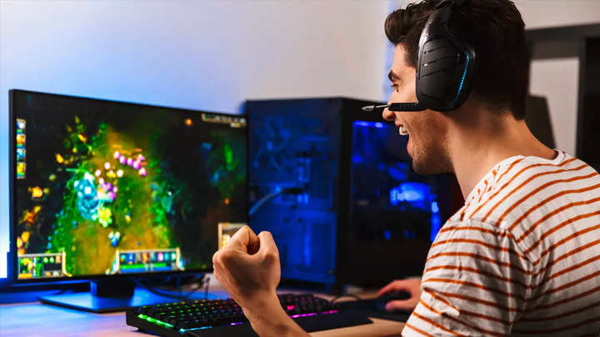

Enhanced Sound Quality
Sound quality is a critical aspect of any gaming experience. Lightweight gaming headphones without mic are often equipped with advanced audio technologies, allowing gamers to immerse themselves in the game's audio landscape. With high-fidelity sound reproduction, precise positional audio, and immersive surround sound, these headphones elevate the gaming experience to new heights.

Durability and Portability
While being lightweight, these headphones do not compromise on durability. They are constructed with sturdy materials that can withstand the rigors of gaming. Additionally, their portable nature makes them convenient for gamers who frequently travel or participate in gaming events. The compact size and foldable designs make them easy to carry without compromising on performance.

Top Features to Look for in Lightweight Gaming Headphones without Mic
When searching for the perfect pair of lightweight gaming headphones without mic, several key features should be considered:

Noise Isolation
To fully immerse yourself in the gaming experience, noise isolation is crucial. Look for headphones that offer effective noise isolation, reducing external distractions and allowing you to focus solely on the game's audio.

Audio Quality
Superior audio quality is a paramount requirement for gaming headphones. Ensure that the headphones you choose offer excellent frequency response, crisp highs, deep lows, and clear mid-range, providing an immersive and detailed audio experience.

Comfortable Design
As mentioned earlier, comfort is a top priority when selecting lightweight headphones for gaming without mic. Look for headphones with cushioned ear cups and an adjustable headband to ensure a comfortable fit for extended gaming sessions. Breathable materials and ergonomic designs can also contribute to a pleasant wearing experience.

Wired or Wireless Options
Consider whether you prefer wired or wireless headphones. Wired options offer a reliable connection and eliminate the need for charging, ensuring uninterrupted gaming sessions. On the other hand, wireless headphones provide freedom of movement and eliminate the hassle of tangled cords. Choose the option that best suits your gaming setup and preferences.

Compatibility
Before purchasing lightweight gaming headphones without a mic, ensure they are compatible with your gaming platform or devices. Whether you're gaming on a PC, console, or mobile device, make sure the headphones you choose are compatible with the audio output of your specific system.

Brand Reputation
Consider the reputation and track record of the headphone manufacturer. Look for brands known for producing high-quality gaming peripherals and headphones with positive reviews from gamers. Established brands often invest in research and development to deliver superior audio performance and durability.

Popular Lightweight Gaming Headphones without Mic
To provide you with some options to consider, here are a few popular lightweight gaming headphones without a mic:

Product A
Product A is a top-rated lightweight gaming headphone without a mic. It features noise isolation technology, delivering immersive sound while blocking out external distractions.
With its comfortable design and superior audio quality, it has garnered positive reviews from gamers worldwide.

Product B
Product B is known for its exceptional comfort and lightweight construction. It offers customizable sound profiles and precise positional audio, enhancing the gaming experience. Its durable build ensures longevity, making it a reliable choice for gamers.

Product C

Product C boasts wireless connectivity, providing freedom of movement during intense gaming sessions. It combines comfort and performance, with excellent audio quality and a long-lasting battery life. Its sleek design and foldable feature make it a convenient option for gamers on the go.

Product D
Product D stands out with its advanced audio technologies, delivering crystal-clear sound and immersive virtual surround sound. Its ergonomic design and adjustable headband cater to gamers' comfort, ensuring a comfortable fit for hours of gameplay.

How to Choose the Right Lightweight Gaming Headphones without Mic
Now that you understand the benefits and features to consider, here are some steps to help you choose the right lightweight gaming headphones without a mic:

Consider Your Gaming Preferences
Reflect on your gaming preferences and the genres of games you enjoy the most. Different games may benefit from specific audio features. For example, if you're a fan of first-person shooters, headphones with precise positional audio can give you a competitive edge.

Set a Budget
Determine your budget range for gaming headphones. This will help narrow down your options and ensure you find a pair that meets both your requirements and financial constraints.

Read Reviews and Ratings
Take the time to read reviews and ratings from other gamers who have used the headphones you're interested in. Their experiences and feedback can provide valuable insights and help you make an informed decision.
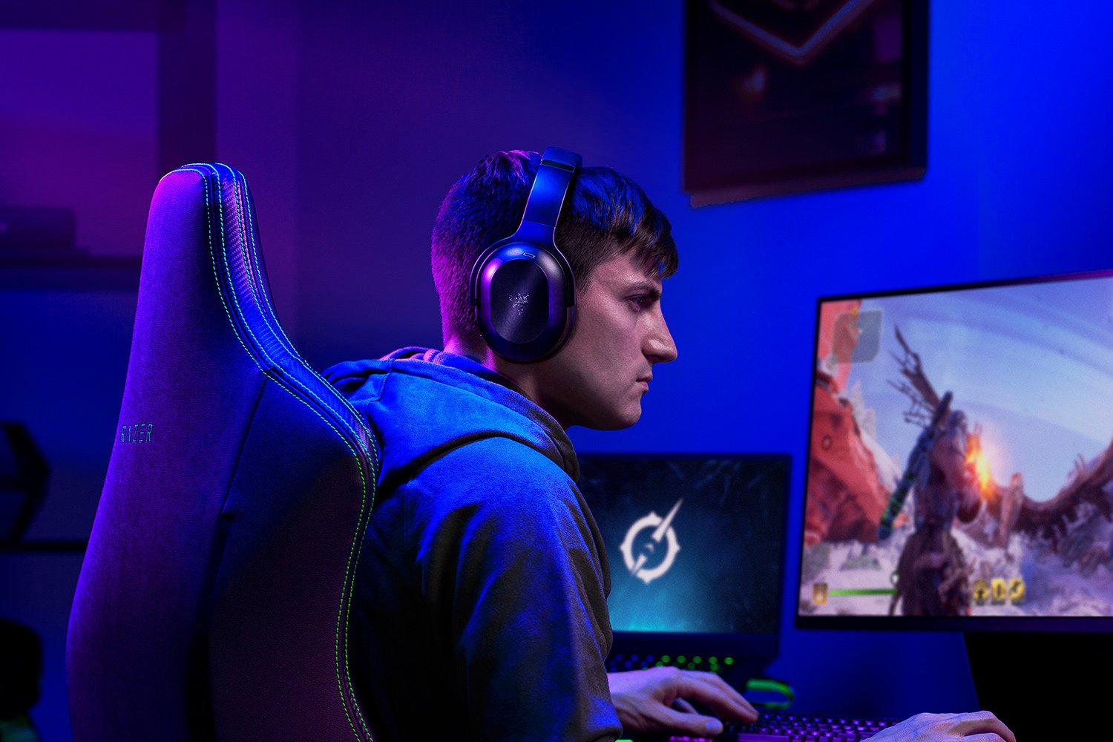

Try Before You Buy
If possible, try the headphones before making a purchase. This will allow you to assess the fit, comfort, and sound quality firsthand, ensuring they meet your expectations.

Conclusion
Lightweight gaming headphones without a mic offer the perfect balance of comfort and performance for gamers seeking an exceptional audio experience. With their focus on comfort, enhanced sound quality, and durability, these headphones provide an immersive gaming experience without the added microphone functionality. By considering the top features and following the steps to choose the right pair, you can elevate your gaming sessions to new heights.

FAQs
Are lightweight gaming headphones without a mic suitable for competitive gaming?
Absolutely! These headphones prioritize comfort and audio quality, which are crucial factors for competitive gaming. Their lightweight design ensures long-lasting comfort during intense gaming sessions, allowing you to focus on your gameplay without any distractions. The enhanced sound quality provides clear and precise audio cues, giving you an advantage in competitive situations where every sound matters.
Can lightweight gaming headphones without a mic deliver immersive audio experiences?
Yes, they can! Despite the absence of a built-in microphone, these headphones are engineered to provide immersive audio experiences. With advanced audio technologies and superior sound reproduction, they can deliver rich, detailed, and immersive audio that enhances your gaming experience. You'll feel fully immersed in the game's virtual world, thanks to the high-quality audio performance of these headphones.
Do lightweight gaming headphones without a mic compromise on durability?
Not at all. While being lightweight, these headphones are designed to be durable and long-lasting. Manufacturers understand the importance of durability in gaming peripherals, and they utilize sturdy materials and robust construction to ensure that these headphones can withstand the demands of regular use. You can rely on their durability to accompany you on countless gaming adventures.
Can I use lightweight gaming headphones without a mic for other purposes besides gaming?
Absolutely! Although these headphones are specifically designed with gaming in mind, they can be used for various other purposes as well. Their high-quality audio reproduction makes them suitable for listening to music, watching movies, or even engaging in conference calls or virtual meetings. Their versatility allows you to enjoy exceptional audio performance across different activities.
What are some affordable options for lightweight gaming headphones without a mic?
If you're looking for affordable options, there are several budget-friendly lightweight gaming headphones without a mic available in the market. Brands such as X, Y, and Z offer reliable and cost-effective options that provide excellent audio performance and comfort without breaking the bank. These headphones are a great choice for gamers on a budget who still want to experience high-quality sound while gaming.

